Process Description of a For Loop

Joe Asbill ENG 2140

**Introduction**

In computer programming, a For Loop is used to loop through a certain block of code a set number of times until its given Boolean expression is false. A For Loop consists of five main parts: an initial value, the Boolean expression, the inside of the loop, an increment statement and the outside of the loop.

**Discussion**

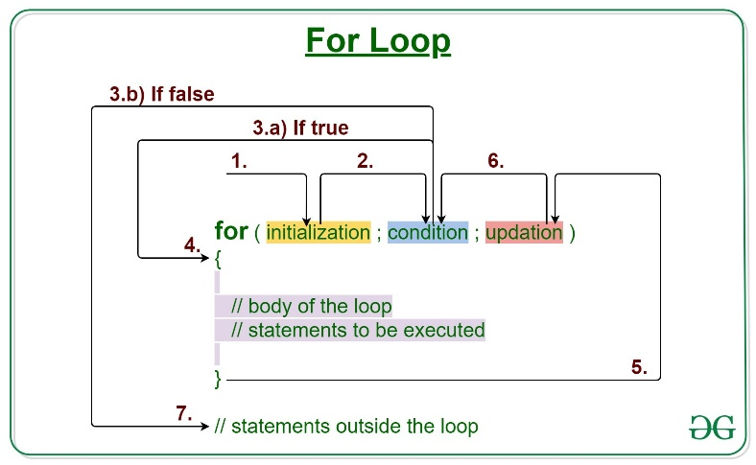

Figure Diagram of For Loop as Seen on GeeksForGeeks.org

Figure Example For Loop (Coded by author)

**Initial Value**

The initial value is the value that begins that cycle of the loop and is the value to be tested in the Boolean expression in the loop.

**Boolean Expression**

A Boolean expression is a statement used to compare two values. Typically, a Boolean expression checks to see if the given value is greater than, less than or equal to a given value. As figure 2 above shows, the value of the variable ‘i’ is being checked to see if it is less than or equal to 10.

**Inside of the Loop**

If the condition checked by Boolean expression is true, the code inside the For Loop is executed. As shown in figure 2, if the condition is true, then the current value in the ‘i’ variable is printed to the screen.

**Increment Statement**

After the code from within the For Loop is run, the increment statement increments the value that began the loop by a specified amount and is tested by the Boolean expression again to see if the loop continues.

**Outside the Loop**

If after the increment, the test by the Boolean expression is false, the loop is ended and the next line of executable code outside of the loop is executed.

**Conclusion**

A For Loop is a process that allows a block of code to be repeatedly executed so long as the current value tests true in the Boolean expression in the loop. The value that starts the loop and the value that tests the initial value are given before the loop starts to determine how long the loop should run. After each execution of the code, the initial value is incremented and the loop restarts with a new initial value until the test is false.

**References**

*Loops in programming*. GeeksforGeeks. (2024a, May 17). https://www.geeksforgeeks.org/loops-programming/